Robot Loading Interface

Installation Instructions

Stage 1 - What You Need Before You Start
- Installed ICW, and Pharmacy, Webs connected to database.
Interface engine folder (available on Home > Software Repository > Ascribe Software Release Repository > Integrated Clinical Workstation (ICW) > Additional Modules > Interfaces > Core EIE)
- RobotLoader folder (released with ICW in ‘Pharmacy Interface’ folder). RobotLoader should always be at same version as Pharmacy application.
- Pharmacy site, the robot will receive goods for.
- Name given to robot location (as define in Pharmacy application)
- Port that robot will use
- Robot Loading test script provided by the Testing team.
Note: You won’t be able to setup two different ARX robot(s) for the same site due to limitations in the order loading screen.

Stage 2 - Interface Engine Installation
- Create directory called “InterfaceEngine RobotLoader”
Note: If connecting to more than one robot create separate interface folder for each (e.g. “InterfaceEngine RobotLoader1”, “InterfaceEngine RobotLoader2”)
- Create sub-directory for each ICW db you are connecting to
e.g. if connecting to ASCICW_Live create a “Live” sub-directory.
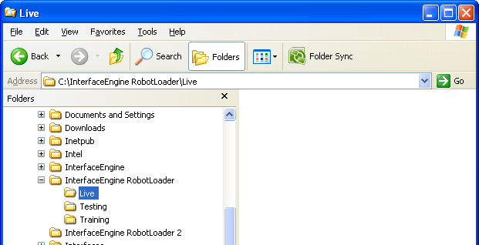
- Copy contents of interface engine folder (available on Home > Software Repository > Ascribe Software Release Repository > Integrated Clinical Workstation (ICW) > Additional Modules > Interfaces > Core EIE) into Live, Testing, and\or Training folders.
Note: Only copy main files not site specific folders.

Stage 3 - Interface Engine Database Configuration
- Run following scripts on ICW database (login as icwsys)
- 1 - Create Interface Table Structure.sql
- 2 - Create Interface Stored Procs.sql
- 3 - Create Interface Metadata.sql
Note: Scripts will be present in C:\InterfaceEngine RobotLoader\Live folder.
- Open ‘Robot Loader Interface configuration script.sql’, edit following values at top of script
Script Variable | Description
@InstallationPath | Path interface engine is installed.  E.g. C:\InterfaceEngine RobotLoader\Live  For 2nd robot will be C:\InterfaceEngine RobotLoader2\Live
@RobotSiteNumber | Pharmacy site robot will receive goods for.
@RobotLocation | Name given to robot location (as define in Pharmacy application)
Note: Script will be present in C:\InterfaceEngine RobotLoader\Live folder.

If connecting to more than 1 robot loader interface engine, update following script variables.
Script Variable | Description
@ServiceName | For second robot change this to RobotLoader2, etc.
@InstanceName | For second robot change this to RobotLoader2, etc.
@LocalRobotPort | For second robot change this to 5512, etc.
@InterfaceEngineUsername | For second robot change this to RobotLoaderInterfaceEngine2, etc.
@IpReceiverUsername | For second robot change this to RobotLoaderIpReceiver2, etc.
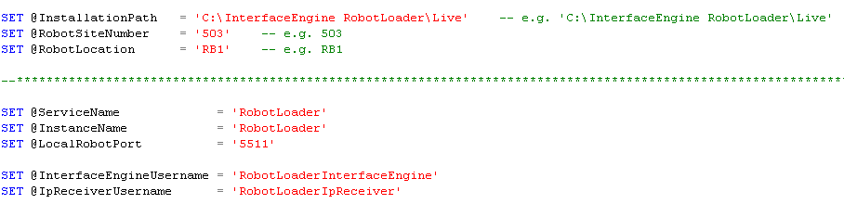

Then run script.
- At end of script output messages there will be a line that reads
Interface Engine Password: <password>
Note down the value.
- If there ISN’T a monitor component installed for another interface engine you will need to run ‘Monitor Component Installation script.sql’ editing following values at top of script
Script Variable | Description
@InstallationPath | Path interface engine is installed.  E.g. C:\InterfaceEngine RobotLoader\Live  For 2nd robot will be C:\InterfaceEngine RobotLoader2\Live
@InterfaceInstanceName | RobotLoader
@PreV9_10Version | 0
@InstanceName | RobotLoader

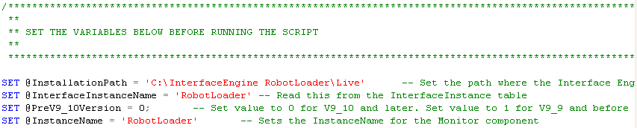

Now run the script
- Open up InterfaceComponent table, and note down InterfaceComponentID of the Monitor component, if there are multiple Monitor components, select the first one.
- To get around problem of Monitor Component timing out when doing the housekeeping, create a new windows scheduled task to run the job manually using OSQL. Create the scheduled task from Start->Control Panel->Scheduled Tasks, entering the following settings:

Setting | Value
File to run | c:\Program Files\Microsoft SQL Server\100\Tools\Binn\OSQL.exe  Note: directory 100 might not be present so try 90, or 80, depending version of SQL installed.
Name | Interface Engine House Keeping
Perform task | Daily at 04:00  By default interface engine will try to run this at 3:00, so schedule it to start at 4:00am so does not affect each other.
Run as | Enter name and password of ascribe access user, used to log on the windows server.

Once created open up the scheduled task, and enter the following extra parameters on the run command
Parameter | Value
-S | Database server name
-d | Database name (normaly ASCICW_Live)
-U | icwsys
-P | Icwsys password
-t | 180
-Q | “EXEC pMonitorTidyMessages 0, {Monitor InterfaceComponentID}, 0”  Where {Monitor InterfaceComponentID} is value noted down in stage 3 step 5 above.

The complete run statement will look something like

"c:\Program Files\Microsoft SQL Server\100\Tools\Binn\OSQL.EXE" -Sdevdb2-2005 -dASCICW_Live -Uicwsys -P{password} –t180 -Q“EXEC pMonitorTidyMessages 0, {Monitor InterfaceComponentID}, 0”

The final schedule will look something like this.

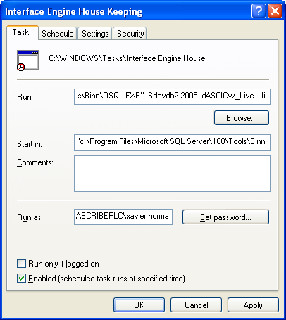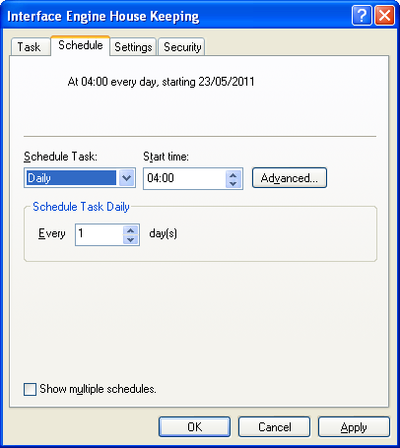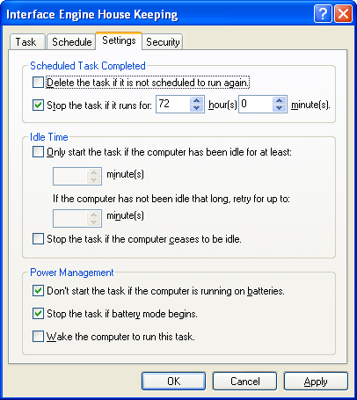

- Start ICW, login, and go to the ICW settings, locate settings where
System: MonitorComponent
Key: MessageRetentionPeriod
Set value to 14

System: MonitorComponent
Key: ErrorRetentionPeriod
Set value to 14

System: Pharmacy
Section: RobotLoading
Key: LimitToDisplyLoadingsFromDate
Set value to 7

Stage 4 - Interface Engine Configuration
- In the interface folder created above (C:\InterfaceEngine RobotLoader\Live) run the ‘Interface Engine Configuration Tool.exe’
- Click the [Change Directory] button, and select the current folder (C:\InterfaceEngine RobotLoader\Live). InterfaceServiceCore.exe.config will be displayed and selected in the list.
- In ‘ICW Type’ select .NET.
- Enter the following values
Variable | Value to set
Interface Engine Instance Name | RobotLoader  (if this is interface for second robot then RobotLoader2 as set for @InstanceName in script above)
Interface Engine Login Username | RobotLoaderInterfaceEngine  (if this is interface for second robot then RobotLoaderInterfaceEngine2 as set for @InterfaceEngineUsername in script above)
Interface Engine Login Password | Interface Engine Password noted above (Stage 3 step 3).
Interface Engine Login LocationID | 0
Service Name | RobotLoaderInterface<instance>  Where instance is Live, Testing, or Training.  If interface is for 2nd robot then set to RobotLoaderInterface2<instance>
Interface Engine Startup Logging | Off
SQL Server Name | SQL server and instance  e.g. localhost\SQLSERVER2005
ICW Database name | ICW db connected to
SQL Server usernanme | Icwsys
SQL Server password | The icwsys password

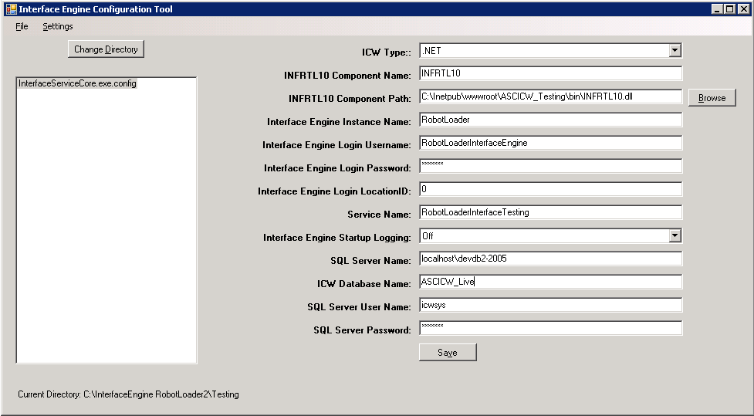

Then in the tool select the Pharmacy Settings tab and enter the following value
Variable | Value to set
Web Site Location | http://localhost/ASCICW_Live_Pharmacy  enter the name of the pharmacy webs for the appropriate version of the interface.

- Open up command prompt, and type following command (N.B. the spaces after the binPath= etc are intended and necessary) replacing <path> with the full path of each of the 3 sub-directories created above and <instance> with the corresponding “Live”, “Training”, “Testing”

sc create RobotLoaderInterface<instance> binPath= “<path>\interfaceservicecore.exe” DisplayName= "<instance> RobotLoader Interface Engine" start= auto

for a second robot use
sc create RobotLoaderInterface2<instance> binPath= <path>\interfaceservicecore.exe DisplayName= "<instance> RobotLoader Interface Engine 2" start= auto
- After this stage you probably deserve a cup of tea, or beverage of your choice!

Stage 5 - Check Start up
- Go to Windows Services and check the service is running. Will be called something like “<instance> RobotLoader Interface Engine”. If not started then manually start it.
- Go to Windows Event Viewer, and select the Application events there should be some new Robot Loader events. Hopefully these are all information type events.
If any errors, check below for possible solutions
Error Event Description | Solution
Cannot open database “<db name>” requested by the login.  The login failed.  Login failed for user ‘icwsys’ | Connection details (set in Stage 4 step 4) are incorrect.  Run the Interface Engine Configuration Tool.exe tool, check the db settings, and then restart the service.
Failed to login to the ICW as RobotLoaderInterfaceEngine | Incorrect Interface Engine Login Password set in Stage 4 step 4.  Run the Interface Engine Configuration Tool.exe tool reset the Interface Engine Login Password noted down in Stage 3 step 3, and then restart the service.  If error is appearing repeatedly, an existing interface engine is using same username and password.
- Open up SQL Server Management Studio and select latest ApplicationLog entries. Check there are no error entries such as
Error Event Description | Solution
Could not load file or assembly &apos;file:///<path>&apos; or one of its dependencies. The system cannot find the file specified. | Component path is incorrect.  Common mistake is to have a double slash on the path name such as C:\InterfaceEngine RobotLoader\Live\\IpReceiver.dll  Manually update the paths in the InterfaceComponent table, and in the ICW setting IPReceiver->RobotLoader->ReplyComponentDllName.  For second robot IPReceiver->RobotLoader2->ReplyComponentDllName.
No destination tables defined for InterfaceComponentID <id> | Ignore this error

Stage 6 – Configure ARX Rowa Robot
Note: Most of this part of the process should be performed by ARX.

The ARX Rowa system will normally have one PC on a table next to the robot, and one for each goods in hatch (normally connected directly to robot). To make it even more difficult the robot PC’s are often connected on a separate LAN from the main hospital (there will be a separate router box connected to Rowa PC).

The steps below should be performed on the, table based PC next to robot.

- In ARX Interface application, click the web link on the top right (just after Backup button)
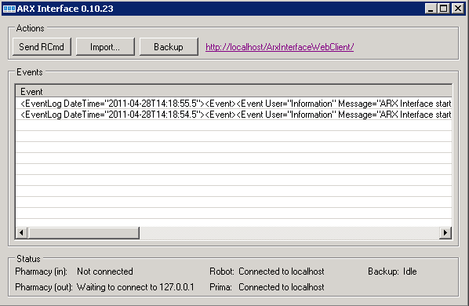
- This brings up following web page, enter username and password provided by ARX.
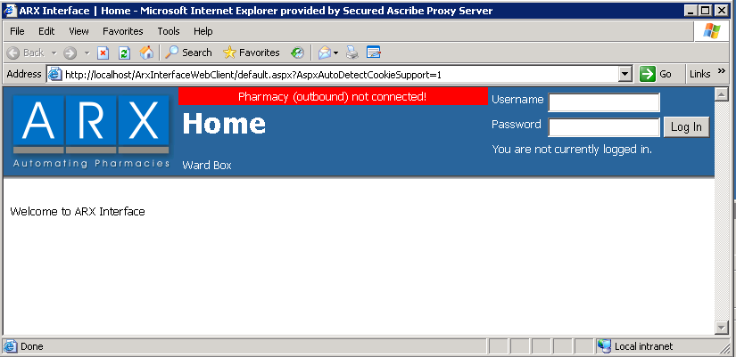
- Once you login a menu will appear along the top. Hold the mouse over Administration (do not click on it) select Configuration, and System Settings.
- List of settings will appear on left, select Pharmacy->HL7->Connection
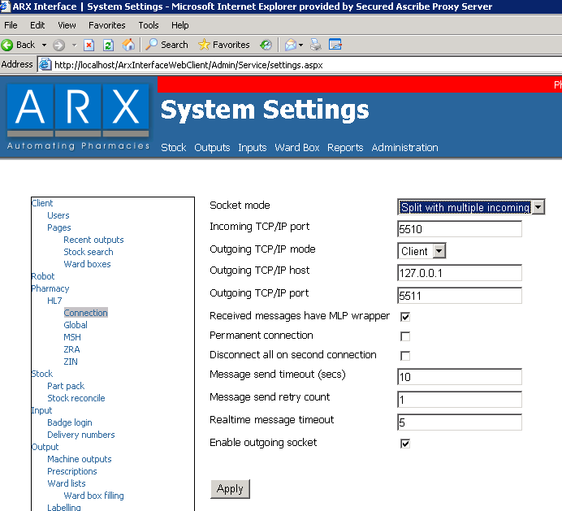
- Enter following values, and click apply.
Setting | Value
Outgoing TCP/IP mode | Client
Outgoing TCP/IP host | IP address of server RobotLoader Interface Engine is running on.
Outgoing TCP/IP port | Port RobotLoader Interface Engine is running on (set in Stage 3 step 2). Can also read the value from the ICW Settings IpRcevier->RobotLoader->LocalIpPort.  Normally 5511, or for second robot 5512.
Received messages have MLP wrapper | Enabled
Enable outgoing socket | Enabled
Keep connection alive (if available) | Enabled
Keep alive time (mins) (if available) | 15mins

Also on menu on left select Input option, and enter following values, and click apply
Setting | Value
Input checking mode | HL7 ZIN sent to pharmacy

- If all goes okay the bar at the top for the web page will change from red to yellow, after a few seconds.
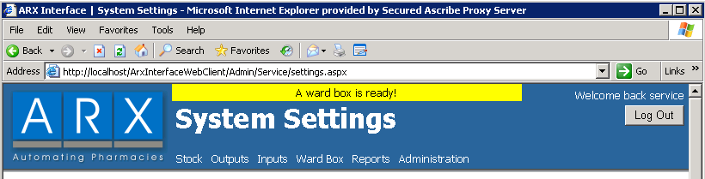
If this does not occur then try these possible troubleshooting tips
- Check the IP address set in the ARX connection setting (Stage 6 Step 5) is set correctly for the PC the Robot Loader Interface is installed on (trying pinging the Robot Loader Interface from the ARX PC)
- Check the port in the ARX connection setting (Stage 6 Step 5) and the ICW settings IpReceiver->RobotLoader->LocalIpPort are the same.
- Check that the Robot Loader Interface Engine service is started.
- Check the Firewall is disabled on both the Robot Loader Interface, and ARX PCs.
- Check ARX Rowa LAN routes connections to the ip address, and port, specified in (Stage 6 Step 5)
- Try using HyperTerminal (from both the PCs connected to the Robot) to connect to the Robot Loader Interface from the ARX PC, on bot
- On Robot Loader Interface PC turn off the interface engine service, and set HyperTerminal to listen mode and seeing if the ARX interface can connect to it.

Stage 7 - Test Sending Messages
This stage tests sending and receiving a valid message between the interfaces.
- On the ARX robot interface you will be able to enter a delivery number (enter anything like 212), and click [Start New Delivery]
- You should receive the reply “Invalid loading number ‘<number>’“

If this does not happen try these troubleshooting tips
- Repeat test above a second time, as may take while for interface to start up.
- In ICW db check Message table to see if new messages have arrived.
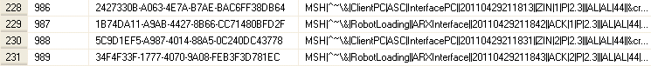
- In ICW db check the ApplicationLog for new errors.
- Login to the Web ARX Interface (Stage 6 Steps 1 to 2) check Inputs, and Outputs->Recent Outputs, for possible errors.
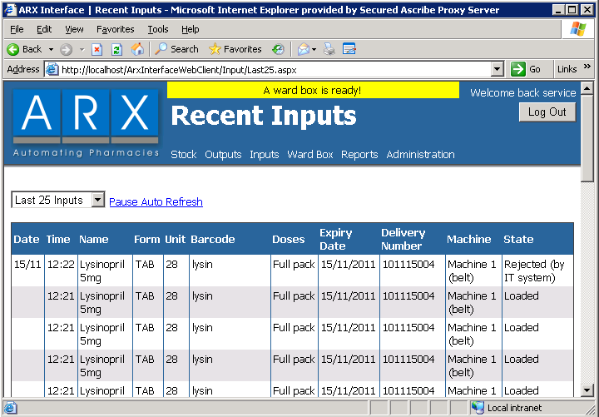
- Login to Web ARX Interface (Stage 6 Steps 1 to 2) Administration->Configuration->System Settings, and for Pharmacy->HL7->Connection setting ‘Received Messages Have MLP Wrapper’ is true.
- For the older style of ARX interface login to Web ARX Interface (Stage 6 Steps 1 to 2) Administration->Configuration->System Settings, and for Pharmacy->HL7->MSH and ensure
Setting | Value
Sending application | ClientPC
Sending facility | ASC
Receiving application | InterfacePC
Receiving facility

Stage 8 – Test Pharmacy RobotLoader
- Start-up and login to ICW.
- Go to Stores desktop on the same site as setup of the Robot Interface.
- In stores go to Orders->Robot Loading.
If this menu option is not enabled, go to ICW settings check there is a setting where
System: RobotLoaderReplyComponent
Key: SiteNumber
Value: <site number>
And there is a setting
System: RobotLoaderReplyComponent
Section: Same section as above
Key: Location
Value: <robot location>
- Also check the following is set to value of 7 if not then update.
System: Pharmacy
Section: RobotLoading
Key: LimitToDisplayLoadingsFromDate
Value: 7
- Orders will only appear in this screen if an item in the order is waiting to receive goods (status 3) for the robot location, and item does not have batch, or expiry date tracking.
- Finally run through the Test teams testing script.

